Skills/Knowledge Related

1- Dirichlet Distribution and Topic Model

http://www.cs.princeton.edu/~blei/papers/BleiLafferty2009.pdf

<http://videolectures.net/mlss09uk_blei_tm/>

2- Graphic model - Bayesian Network

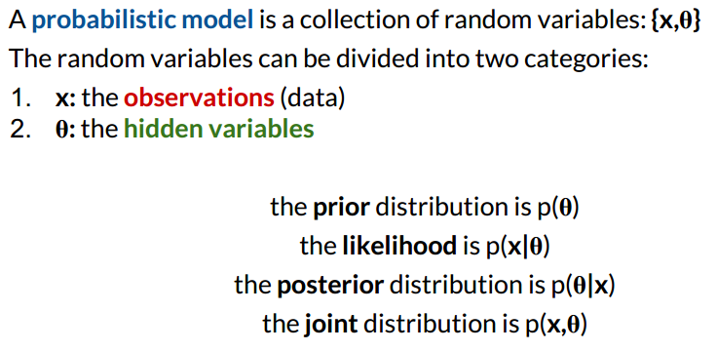

3- Bayesian Chain rule

https://en.wikipedia.org/wiki/Chain_rule_(probability)



4- Optimization - Lagrange Multiplier

5- Expectation Maximization

<https://en.wikipedia.org/wiki/Expectation%E2%80%93maximization_algorithm#M_step>

<https://d1b10bmlvqabco.cloudfront.net/attach/hxwaa1bxuze4xj/hz2w5mtluog222/i26u9rcahm25/probabilistic_models.pdf>

<https://www.youtube.com/watch?v=hLTvGAR3FQU&feature=youtu.be&t=29m53s>

6- Gaussian Mixture Model

http://pillowlab.cps.utexas.edu/teaching/CompNeuro10/slides/slides18_EM_MOGandFactorAnls.pdf

Key problem for now

1- energy function/divided by zeros?

2- maximize by lagrange multipliers